**1.What is software? What is software engineering?**

* software

defination:

Software is a set of instruction, data or program used to oprate computers and excute specific tasks.

Use:

It helps the device understand what to do and how to do it.

Example:

Web browsers

Graphics software

Operating system

Database

* software engineering

defination:

software engineering is the branch of computer science that deals with the design, development, testing and maintenance of software applications.

Use:

Software engineers apply engineering principles and knowledges of programming languages to build software solutions for end users.

Example:

Develop computer games

Business application

**2.explain types of software?**

The two main categories of software :

* System software

operating system

language processor

Device Driver

* Application software

General purpose software

Custmoize software

utility software

system software:

system software is software that directly operates the computer hardware and provides the basic functionality to users as well as to the other software to operate smoothly.

Example:

Operating systems

Linux

Android

Microsoft windows

Application software:

Software that performs special functions or provides functions that are much more than the basic operation of the computer is known as application software

Example:

Firefox

Google chrome

Microsoft word and excel

**3. What is SDLC ? Explain each phase of SDLC**

**Software development life cycle is a structured process that is used to design, develop, and test good-quality software.**

Use:

SDLC is use to design and build high-quality software.

Each phase of SDLC:

Planning

Analysis

Design

Development testing

Implementation

maintenance

* Planning

The planning phase of the SDLC is also when the project plan is developed that identifies, prioritizes, and assigns the tasks and resources required to build the structure for a project.

* Analysis

The analysis phase also gathers business requirements and identifies any potential risks

* Design

The design phase of the Software Development Life Cycle is a critical step in developing the conceptual blueprint of a software project.

* Development test

The actual development phase is where the development team members divide the project into software modules and turn the software requirement into code that makes the product.

* Implementation

The implementation and testing phase is a stage in the software development life cycle where the software testing plan is created, implemented, and executed.

* Maintenance

The maintenance phase of the SDLC occurs after the product is in full operation.

**4. What is DFD ? Create a DFD diagram on Flipkart.**

Defination:

Data Flow Diagram (DFD) represents the flow of data within information systems. Data Flow Diagrams (DFD) provide a graphical representation of the data flow of a system that can be understood by both technical and non-technical users.

Use:

DFDs help for better understand process or system operations to discover potential problems, improve efficiency, and develop better processes.

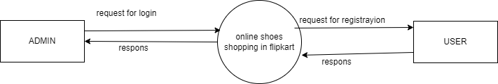

[ fig: DFD level-0]

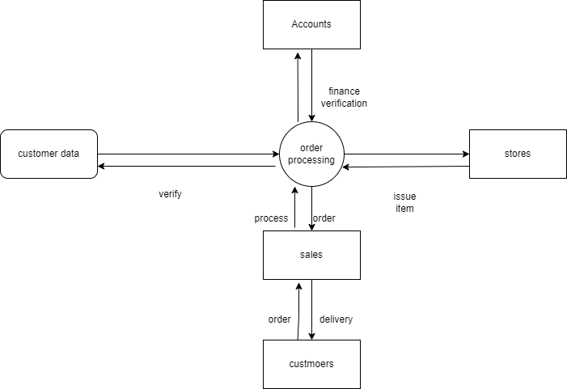

[ fig: DFD level-1]

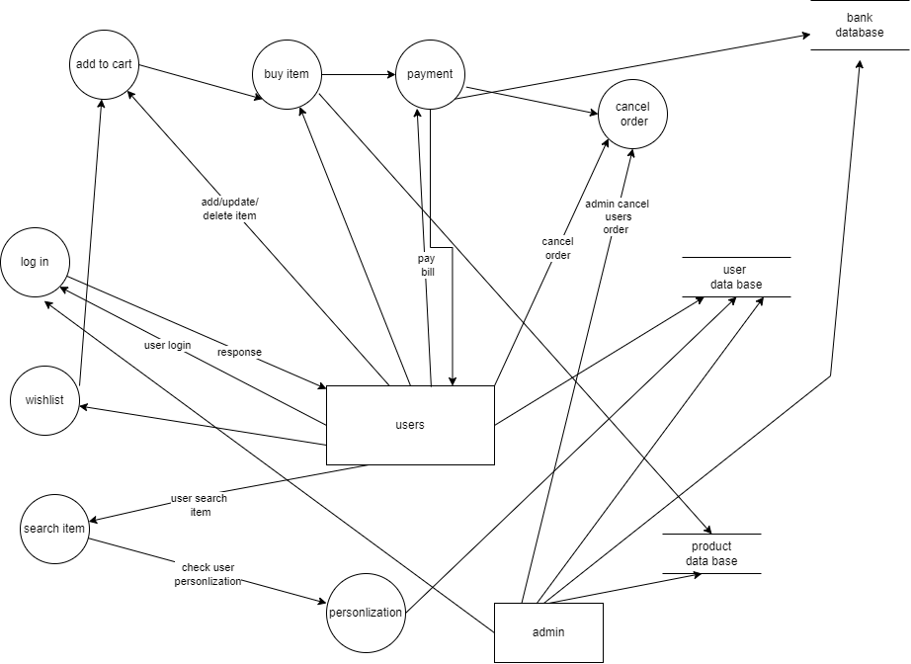

[ fig: DFD level-2]

**5. What is a flow chart ? Create a flow chart to make addition of two numbers.**

Defination:

A flowchart is a diagram depicting a process, a system or a computer algorithm

Use and example:

It organises the tasks in chronological order and identify them by type, e.g. process, decision, data, etc.

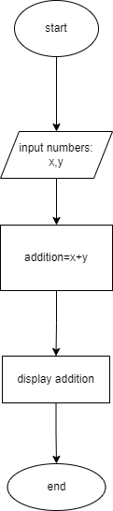

[fig: flowchart for addition two numbers]

**6. What is use case diagram? Create a use case on bill payment on paytm.**

Defination:

Use-case diagrams describe the high-level functions and scope of a system.

These diagrams also identify the interactions between the system and its actors.

Use:

Use-case diagrams describe the high-level functions and scope of a system

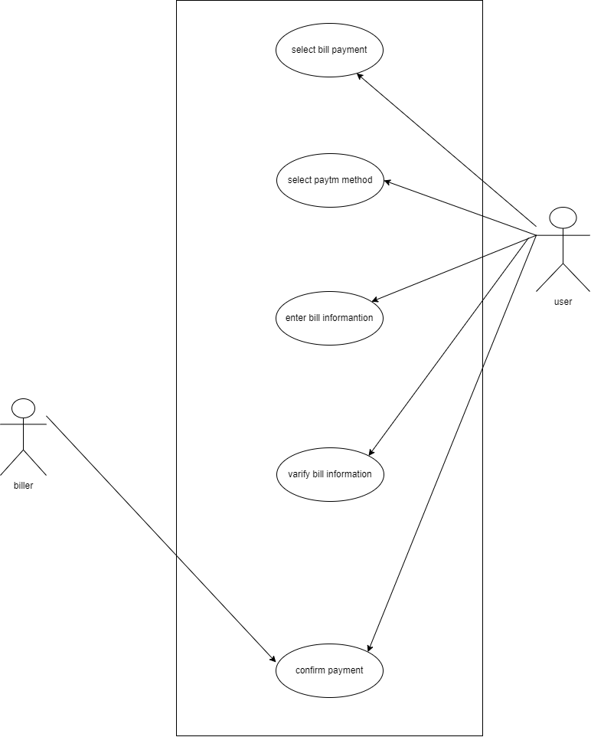

[ fig: use case diagram on bill payment on paytm]